ASSIGNMENT:
SHOPPING-BASKET

Repository: https://github.com/SIndustryPortfolio/WEBSITE-Shopping_Basket

Contents
Introduction 3
Backend 3
Database 3
Implementation 4
Architecture 4
Definitions & Behaviours: 7
Frontend 10
Implementation Choice 10
Architecture 10
Why typescript? 12
Potential Improvements 12
Summary 13
References 14

Introduction
The problem:
A pricing component is required to calculate the subtotal, discount & total of digital user baskets; the main focus is to produce a checkout-style “pricer” service called “BasketPricer” which performs the calculations and returns them to the main app.

My approach:
To build this component alone would be quite a small and easy project. So contextually judging from the job specification alongside the project requirements it would be much more reasonable to produce a project that satisfies the language requirements, this being a website.
The website will be responsible for handling user baskets, calculating all prices and providing a user friendly interface to interact with core components.

Backend

Database
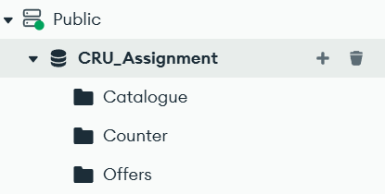
Figure 1 Relations breakdown
The core relations needed to create a fully functional app:
Counters: Used as an alternative to SQL DB’s “Auto-increment” for Integer based IDs -> Basket IDs (This is now deprecated, IDs are now bound to IPs for the web demo)
Offers: Stores offer / discount collections mapped to product names & families
Catalogue: Holds all raw product information
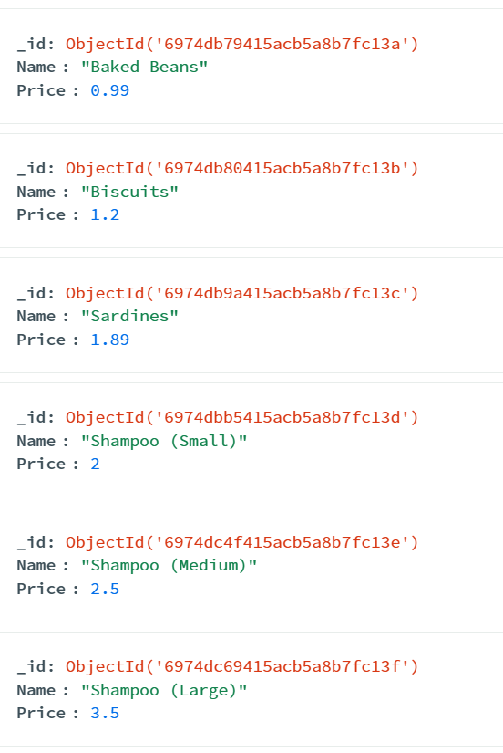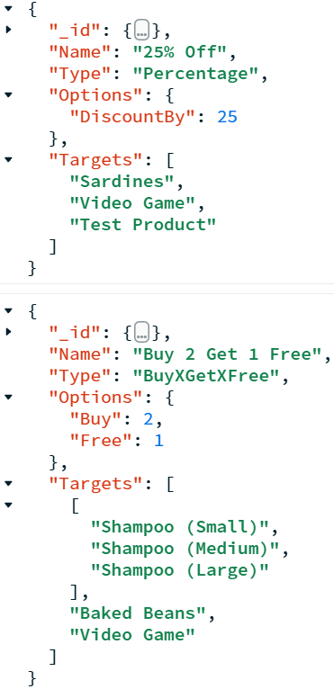
Figure 2 Catalogue Documents Figure 3 Offer Documents
Offers are identified via their name and are configurable via their “options”. Offer targets can be individual and can come in families for offer-group discounts. Offer data is parsed into a cache of JSON-style key value pairs.
Catalogue products are cached similarly but into objects for distinctness & serialisation for quicker templating through JINJA2: “GetDict()”.

Implementation
Type | Names
Languages | Python
Libraries | Flask, os, threading, pymongo, importlib, json, time, datetime, copy

Architecture
In true website fashion, I opted to use MVC or more commonly known as the “Model View Controller” design pattern for “event” driven functionality. This made it easy to abstract a modular architecture into 3 main categories: Views (Templates), Controllers (Routing) and Model (Logic & Data).

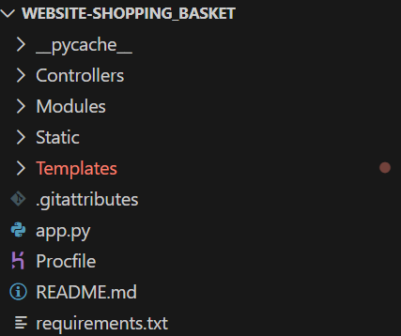
Figure 4 Root file structure. Ignore Error highlight -> IDE doesn’t have native JINJA2 syntax support
All major app components are kept centralised into relevant folders for ease of access during development. Folders are bound to the web server’s core routing, for example, the “static” folder is assigned to “/Static”.
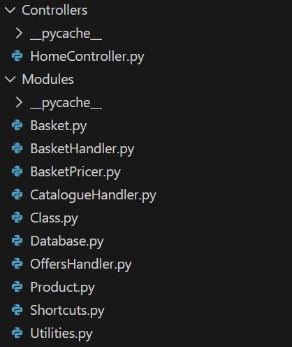
Figure 5 Backend services & objects
How do I bring all these files into a singular application? This is done by the use of the “main” file, “app.py” which contains bulk module importing (an ideology derived from my game development).
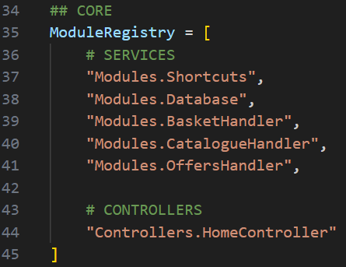
Figure 6 Module paths cached in an ordered registry
All python files with “Initialise” / “End” / “Heartbeat” methods are placed into a module registry for readability inside the main app. An alternative can be done via iterating through files via a directory but imports need to be in order for caching and setup purposes hence why paths are hard-coded.

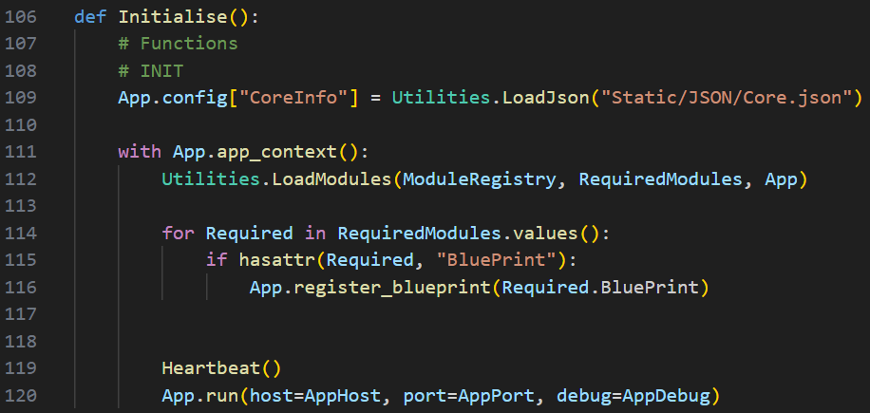
Figure 7 Main class Init code
Web server start-up: All registry modules initialised, cached and potentially attached to the app for routing purposes. This method is exception handled to ensure the application ends and is correctly memory managed (doesn’t consume more web deployment resources than it should).
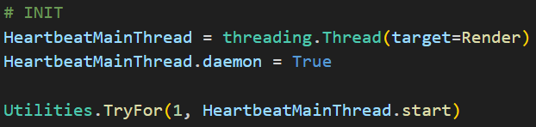
Figure 8 Heartbeat thread
A custom thread which creates a runtime loop. When bound to via the module registry, it provides real-time update via “heartbeat” callback methods. This is primarily used for TTL (time to live) purposes for runtime caching: Clearing session baskets after 30 minutes of inactivity.

Definitions & Behaviours:
“basket: A collection of goods a customer wishes to buy.
A basket can contain zero or more products.”
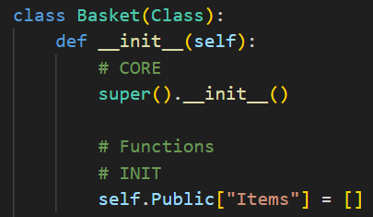
When a basket is created, it holds a list object with 0 items inside. List objects can store a dynamic length of items.

“A basket is mutable - that is to say products can be added to it.”
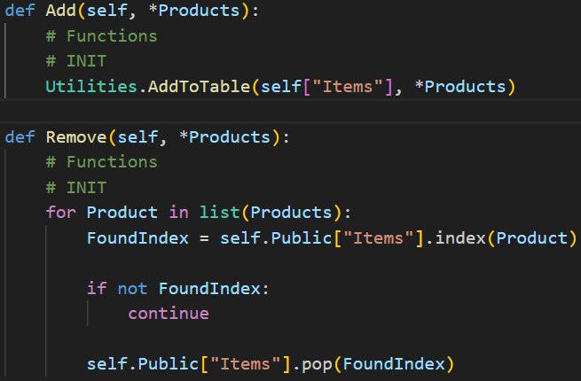
Baskets have shorthand Add and Remove methods to modify item contents.
Products are referred to as “items” as they’re shallow cloned maybe added and removed from the basket.

“An empty basket has a sub-total, discount and total each of zero.
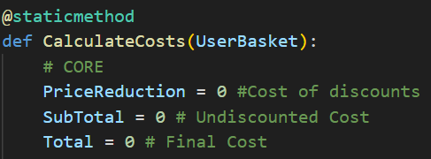
Baskets themselves do not hold the price, that is for the “Basket-Pricer” component to decide. Checkout terms are defaulted at 0 and will stay 0 for empty baskets.

“Baskets cannot have a negative price.”
Costs are double clamped numbers before rounding to ensure costs don’t fall below or exceed said values.

“Discounts should be applied fairly”
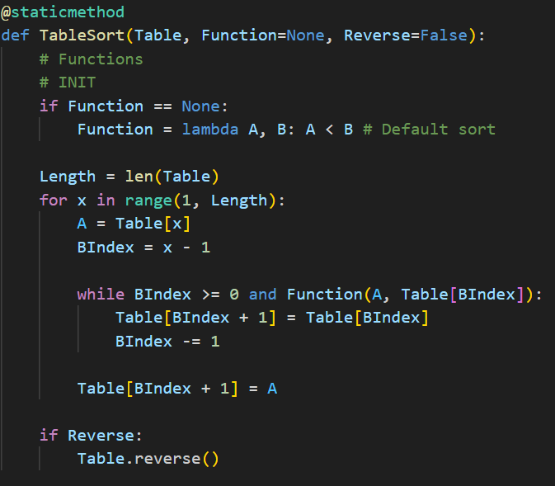
Figure 9 Luau style sorting algorithm
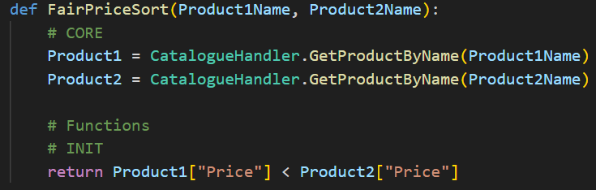
Figure 10 The fair price function passed to the sorting method
Lua style “table.sort” method for custom sorting. Discount families are passed through and sorted from cheapest to most expensive when loaded server-side regardless of original order. We assume products aren’t sorted as different teams handle different components so solutions must be reliable for potential edge cases.

“The discount and therefore the total price is determined by the contents of the basket, the undiscounted price of the goods and the applicable offers.”
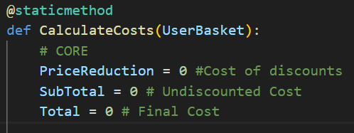
All costs are calculated on the session basket object which holds items. The volatile contents of the basket which are items hold price values. Memory is conserved as these items expire once the basket is garbage collected. The original cached products aren’t affected.

“As with all supermarkets, the prices of goods and the offers applicable to those goods may change from day to day and therefore cannot be hard-coded into this component.”
Items aren’t hard-coded, they are loaded and cached into the app from a separately hosted web database: MongoDB.
We assume another team has handled the pricing of these items; the apps job is to load and cache all item meta-data. Also, the main “Basket-Pricer” component is to be modular and re-usable so it should accept multiple different catalogues for different use-cases.

“Catalogue and offers are maintained by two different teams. It's possible that there are offers on products which are no longer in the catalogue. It's also possible that there are items in the catalogue with no offers, or multiple offers.”
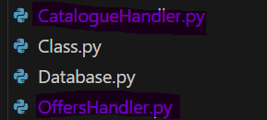
Figure 11 Separated backend services
Both services are separated within the application’s module space to replicate how they could be maintained by multiple teams.

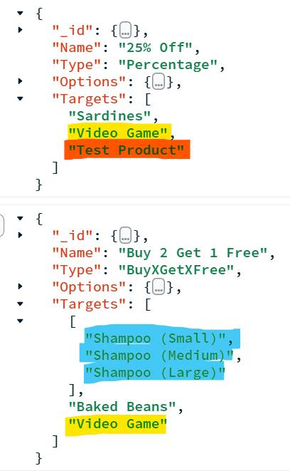
Figure 12 Final Offers Collection Documents
Offers can be applied to:
None-existent items: “Test Product”
Families: “Shampoo (Small)”, “Shampoo (Medium)”, “Shampoo (Large)”
The same product: “Video Game”

Find testing & results on read me.md

Frontend

Implementation Choice
Type | Names
Languages | Typescript, JavaScript, JINJA2, HTML, CSS
Libraries | Bootstrap, npm

Architecture
Similarly, the frontend also follows the modular system design: service-oriented & layered.
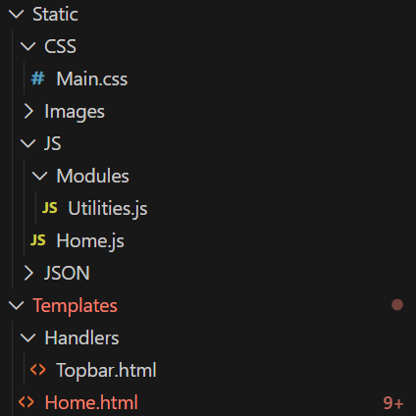
Figure 13 Front end structure
Templates, CSS & JS files are layered; Every web page will have a top bar, within this top bar all “skeleton” page structure is imported including external scripts: Bootstrap and internal material like the main style sheet.
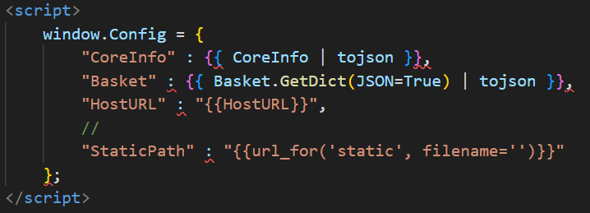
Figure 14 Rendering / Parsing variables as JSON

Also, the top bar is a critical element to parse globals sent from the server-side. The invalid syntax highlights come from the lack of text-editor dependencies: No current installed extension for JINJA2.
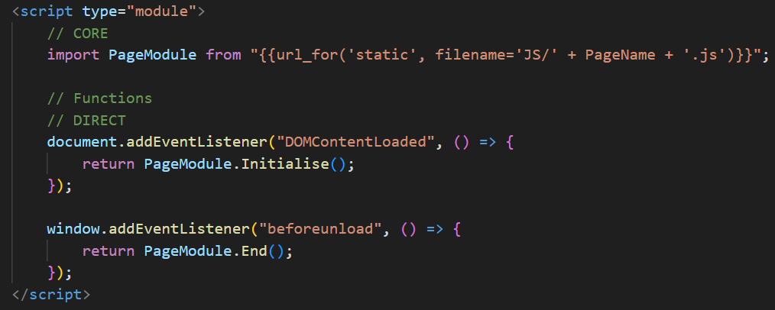
Figure 15 Module import & "knit" event management
And page specific code is imported into the page source including “Initialise” and “End” knowledge for start-up and clean-up purposes.

[EDIT: 06/02/2026]
Ported JS front-end to Typescript for a more production-ready website preventing all common errors taking the “sad path” to make a concrete front-end preventing edge-case errors.
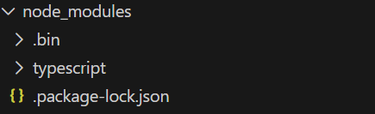
Figure 16 Imported node.js modules and TS package
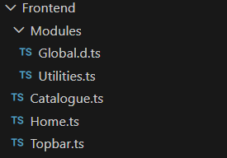
Figure 17 Pre-compiled Typescript front-end structure

Why typescript?
After porting to TS, appending changes to the web app is much easier because of the real-time type checking throwing potential compilation errors during coding with contextual reasoning.
Also, committing changes is less difficult as the source and the compiled JS are 2 separate directories. The “tsconfig” file is setup to not auto compile changes allowing development and production to be separated by an extra layer.

Potential Improvements
If given more time, additional functionality can be added to the web app such as:
- AJAX / Socketio real-time client-server communication when adding / removing products
- Pagination, search, “filter by” and “sort by” for more products
- Create users & credit balances to use in the shop
- Port frontend to react.js / vite app
- Have the basket pricer component shared between server-side and client-side for less page lag / interference
- Create REST API for better integration with other marketplaces

Summary
Clarifications
• Basket identity is session-scoped and IP-bound for the web demo. Counter-based IDs are deprecated.
• Monetary values are clamped and rounded to prevent negative totals and floating-point drift.

Pricing & Offer Rules
• Subtotal is calculated exclusively from catalogue prices.
• Discounts are derived only from applicable runtime offers.
• Multiple offers are resolved deterministically to avoid double-counting.
• Offers targeting non-existent catalogue items are ignored safely.

Caching & Performance
• Catalogue and offer data are cached in-memory on startup.
• Session baskets expire after 30 minutes of inactivity via the heartbeat thread.

Testing
• Pricing logic validated using known baskets and expected totals.
• Edge cases include empty baskets, offer-only items, expired sessions, and conflicting offers.
• Full test notes and results are documented in README.md.

Limitations & Future Improvements
• IP-bound sessions are demo-only; authenticated sessions are recommended for production.
• Offer resolution could be extended with prioritisation or exclusivity rules.
• Currency handling is currently single currency.

References
- SIndustryPortfolio (2026) WEBSITE-Shopping_Basket [online]. GitHub. Available at: https://github.com/SIndustryPortfolio/WEBSITE-Shopping_Basket (Accessed: 29 January 2026).

- SIndustryPortfolio (2026) Shopping Basket – supermarket basket pricer web app [online]. Available at: https://shopping-basket-87c673649f49.herokuapp.com/ (Accessed: 29 January 2026).

